Practical No: 6
Practical 6: Perform structured analysis (SA) to convert analysis model into Data Flow Diagram
(DFD) up to level 2.

Level | Purpose | Our E-Commerce DFD
Level 0 | Represents the complete system as one process. | E-Commerce Website
Level 1 | Decomposes the complete system into major processes. | Six processes from 0.1 to 0.6
Level 2 | Further decomposes Level-1 processes into smaller functions. | Detailed subprocesses 0.1.x to 0.6.x

a) Level 0 Data Flow Diagram:
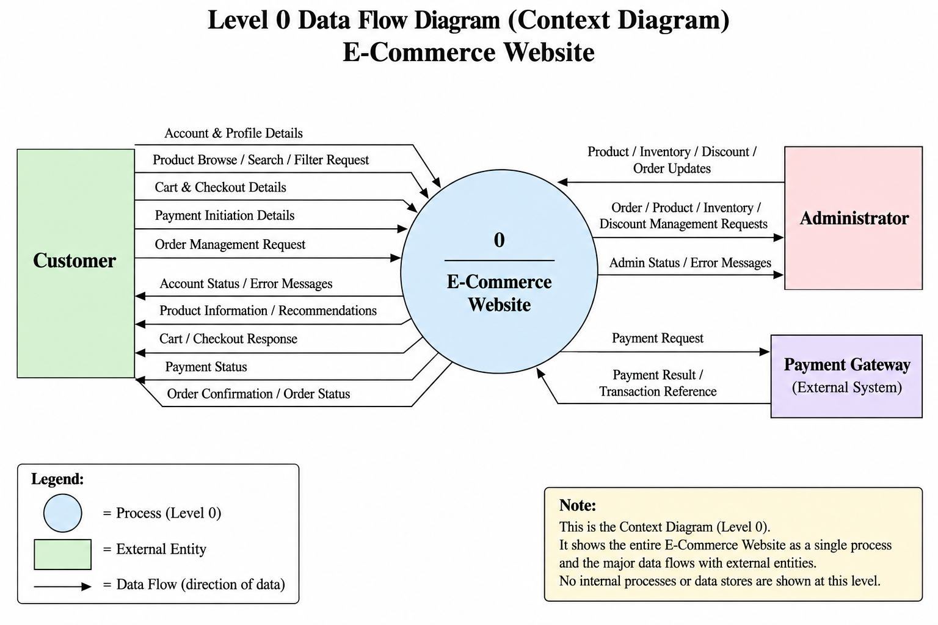
b) Level 1 Data Flow Diagram:
Process No. | Process Name | Main Purpose
0.1 | Manage Customer Account | Manage registration, authentication, profile and delivery addresses
0.2 | Browse and Search Products | Browse, search, filter and view product information
0.3 | Manage Cart and Checkout | Manage cart items, validate availability, discounts and prepare checkout
0.4 | Process Orders and Payments | Validate orders, check stock, process payments and manage order status
0.5 | Generate Product Recommendations | Generate recommendations using customer activity and product information
0.6 | Manage Administration | Manage products, inventory, discounts/coupons and orders

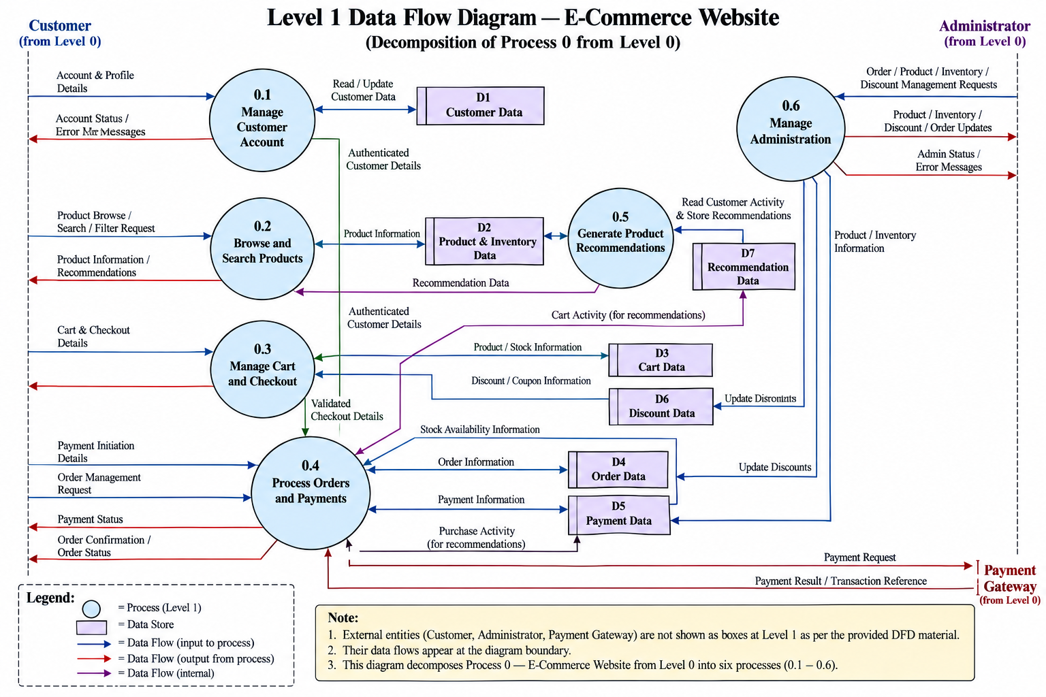
c) Level 2 Data Flow Diagram:
Level 2 provides a more detailed decomposition of each Level-1 process.
Each parent process is divided into smaller subprocesses representing meaningful functional transformations.
Parent Process | Level-2 Processes
0.1 Manage Customer Account | 0.1.1 Register Customer, 0.1.2 Authenticate Customer, 0.1.3 Manage Customer Profile, 0.1.4 Manage Delivery Addresses
0.2 Browse and Search Products | 0.2.1 Browse Products, 0.2.2 Search Products, 0.2.3 Filter Products, 0.2.4 View Product Information
0.3 Manage Cart and Checkout | 0.3.1 Manage Cart Items, 0.3.2 Validate Cart and Product Availability, 0.3.3 Validate Discount and Calculate Total, 0.3.4 Validate and Prepare Checkout
0.4 Process Orders and Payments | 0.4.1 Validate Order Details, 0.4.2 Check Stock Availability, 0.4.3 Process Payment, 0.4.4 Handle Payment Result, 0.4.5 Manage Order Status and Confirmation
0.5 Generate Product Recommendations | 0.5.1 Collect Customer Activity, 0.5.2 Analyze Activity and Product Data, 0.5.3 Generate Product Recommendations, 0.5.4 Store and Provide Recommendations
0.6 Manage Administration | 0.6.1 Manage Products and Inventory, 0.6.2 Manage Discounts and Coupons, 0.6.3 Manage Orders and Order Status

0.1 Manage Customer Account :
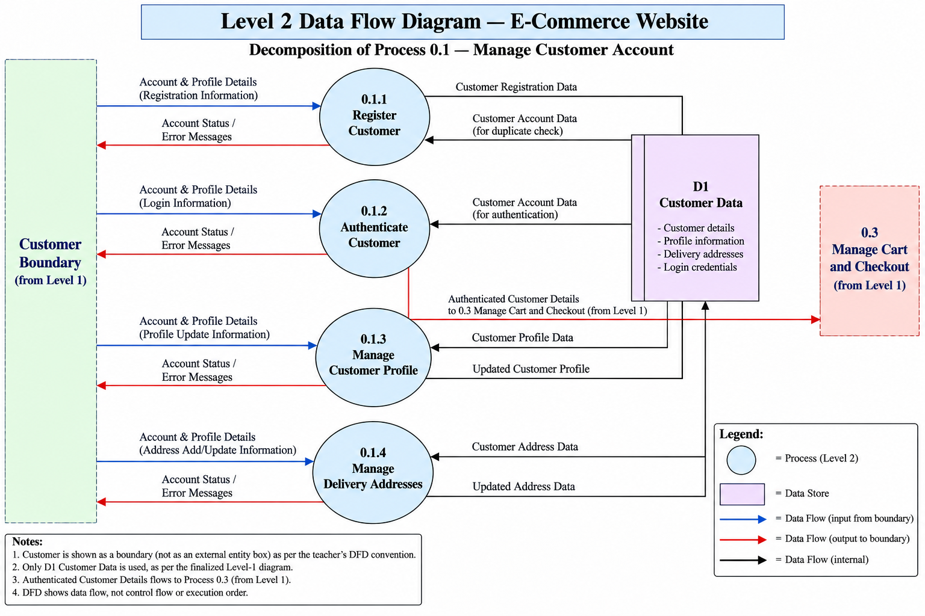
0.2 Browse and Search Products :
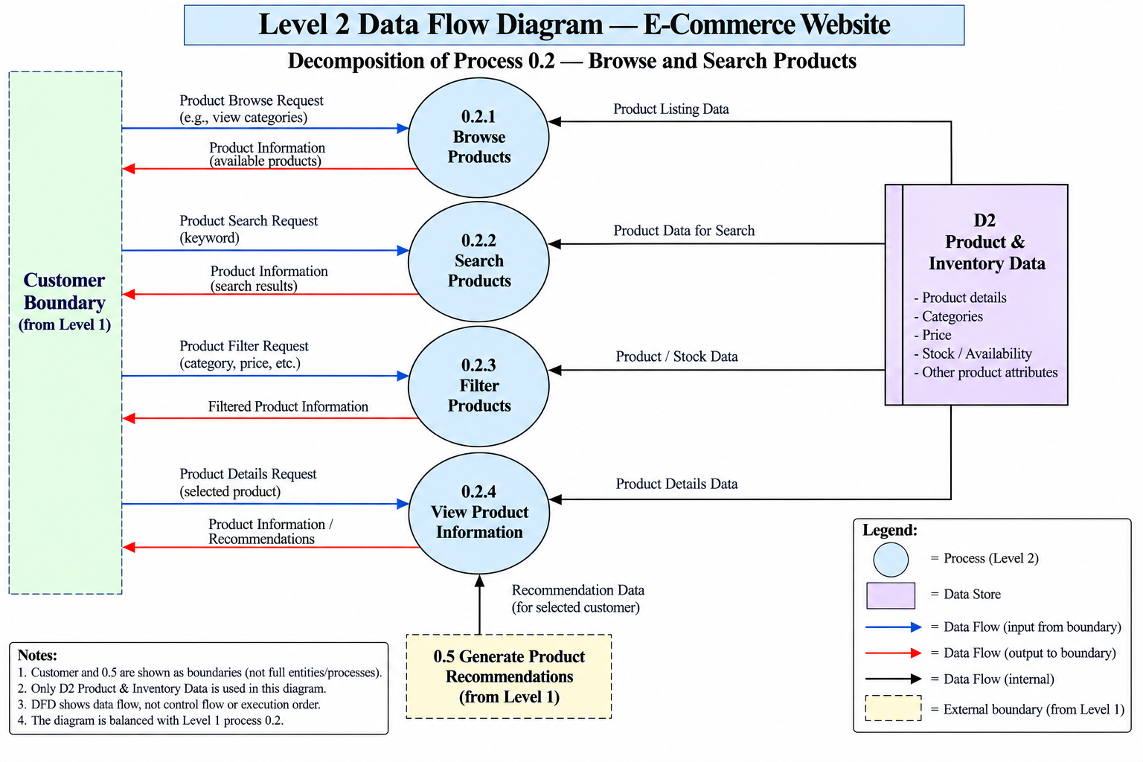
0.3 Manage Cart and Checkout :
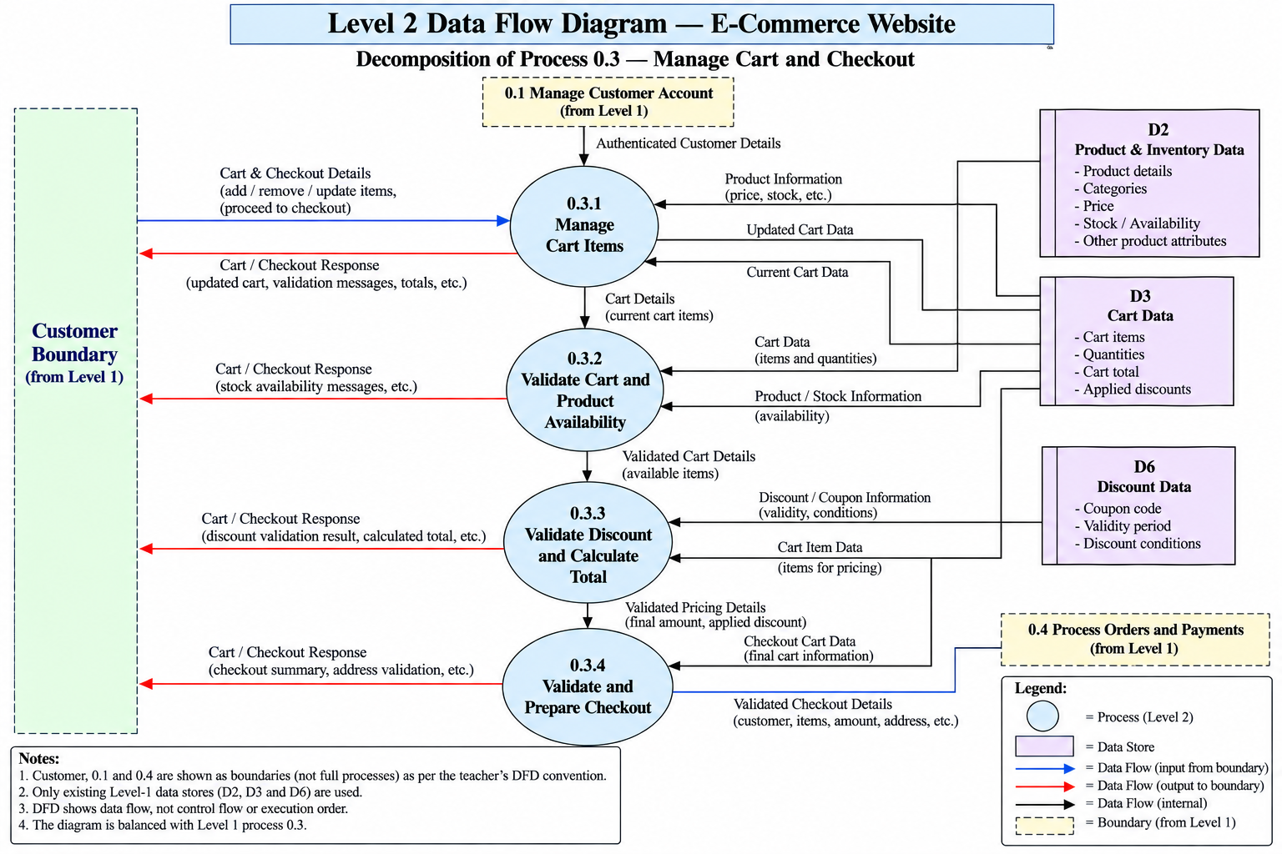
0.4 Process Orders and Payments :
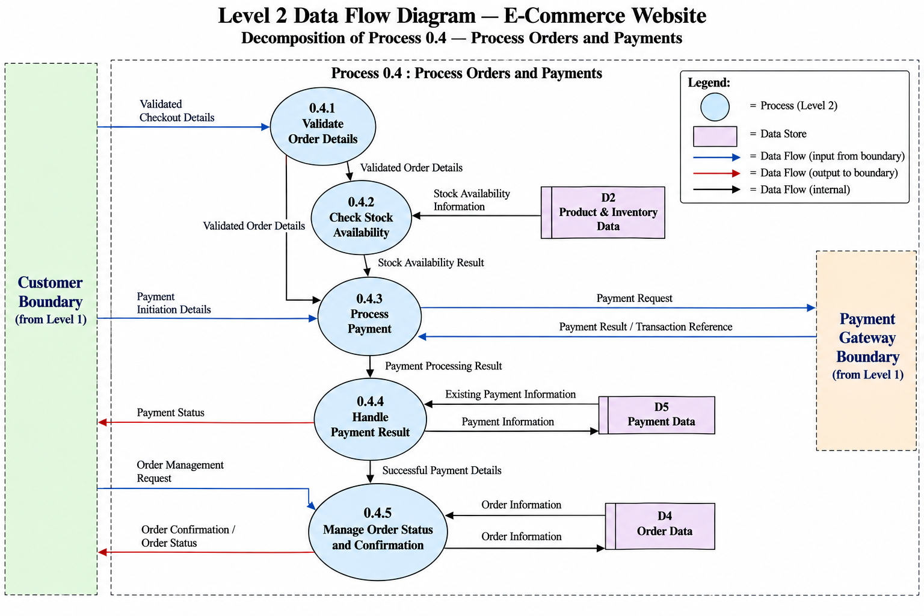
0.5 Generate Product Recommendations :
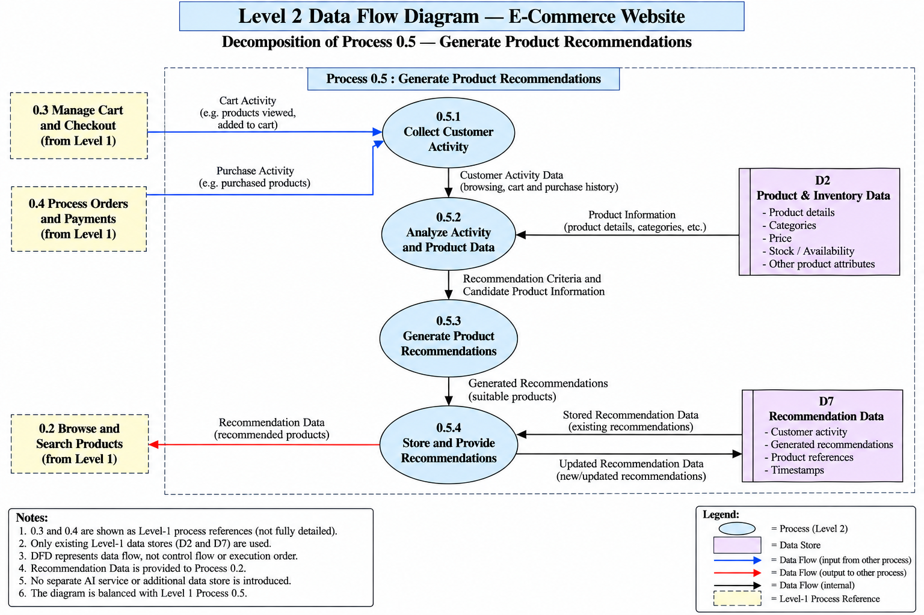
0.6 Manage Administration :
